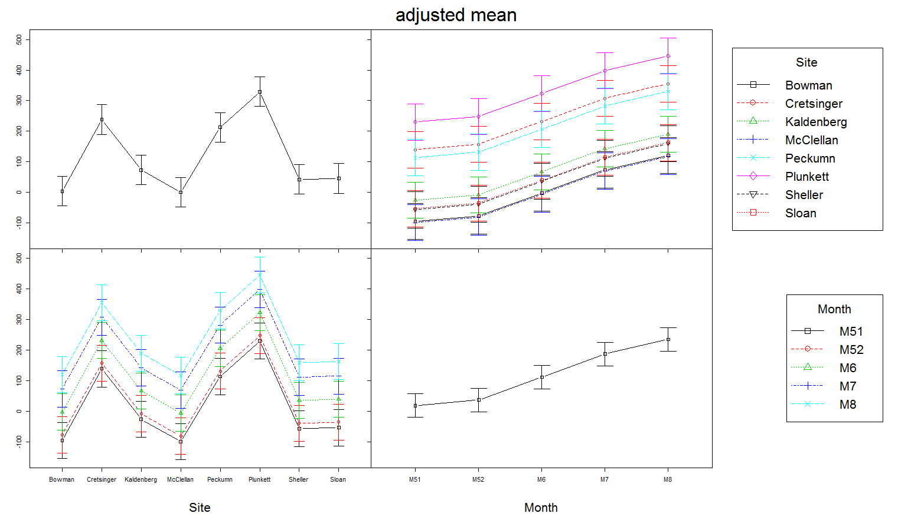

Forb coverage (lm model)



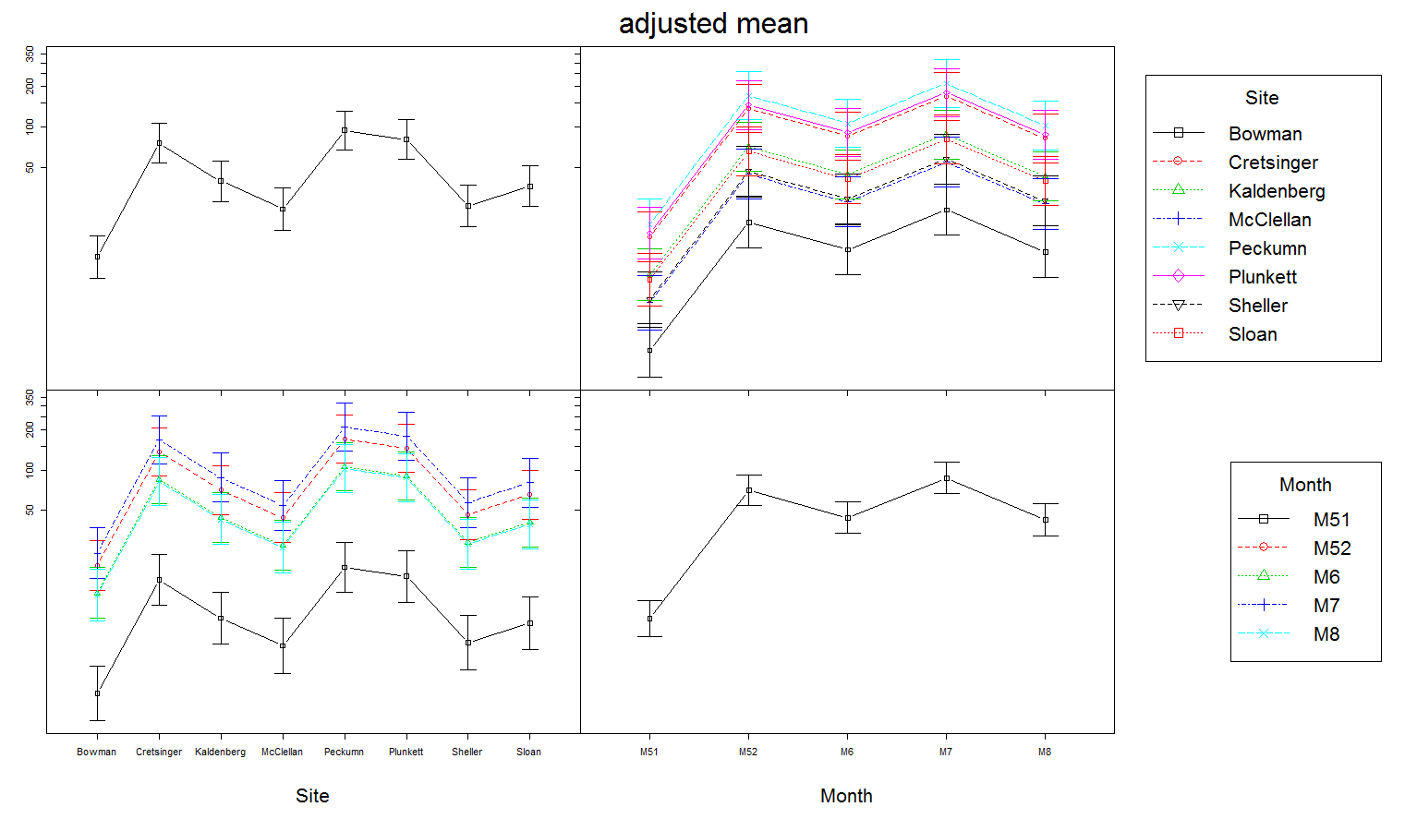Bee abundance (glmer model)

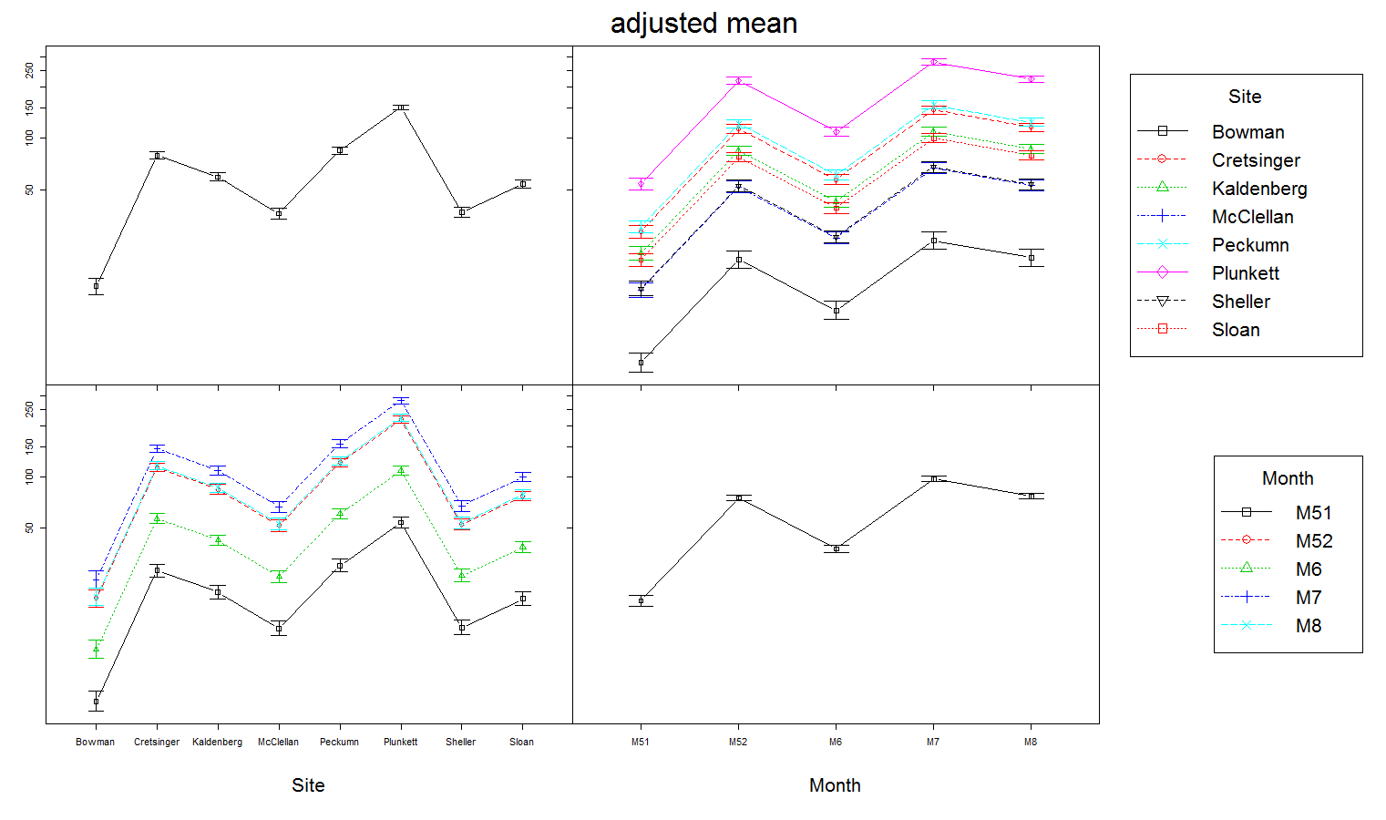Bee abundance (glm model)

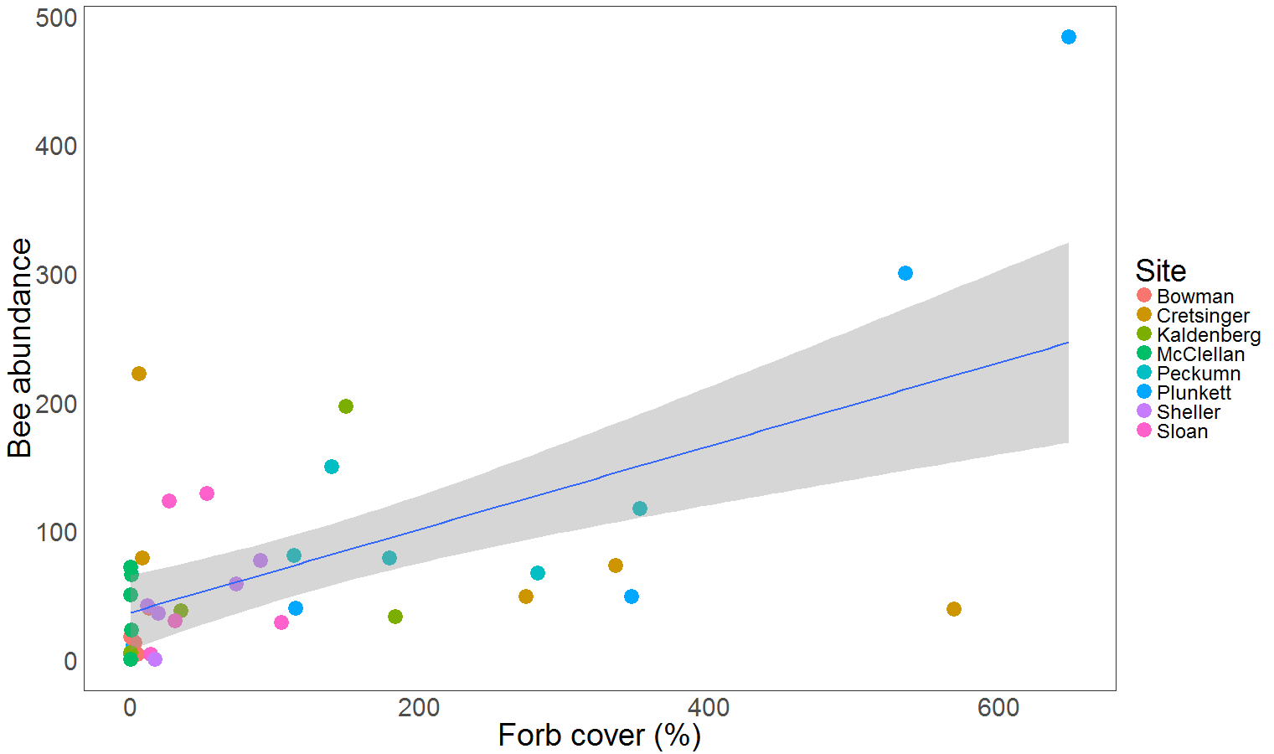

r= 0.60 ***

beeMorgan<-read.csv("C:/Field data-2016/Morgan/MMackert.csv")

library(lme4)

require(phia)

library(car)

library(AER)

any(is.na(beeMorgan))

#overdispersion test with glm model

BE <- glm(Total_Bees~ ., data = beeMorgan, family = poisson)

dispersiontest(BE,trafo=1)

#No Over dispersion so

#Use glm for Total_Bees

mm <- glm(Total_Bees ~ Site + Month,family = poisson,data=beeMorgan)

summary(mm)

plot(interactionMeans(mm),cex=2,cex.main=2, cex.lab=2,cex.axis=1)

###############

#Test glmer for Total_Bees

mmm <- glmer(Total_Bees ~ Site + Month + (1|Site:Month),family = poisson,data=beeMorgan)

summary(mmm)

plot(allEffects(mmm))

allEffects(mmm)

plot(interactionMeans(mmm),cex=2,cex.main=2, cex.lab=2,cex.axis=1)

#####################

#Use lm for plant coverage data

plant <- lm(Total_Plants ~ Site + Month,data=beeMorgan)

summary(plant)

plot(interactionMeans(plant),cex=2,cex.main=2, cex.lab=2,cex.axis=1)

#############################

#Correlation test between plant cover and bee abundance

cor.test(beeMorgan$Total_Plants,beeMorgan$Total_Bees)

#Correlation plot in ggplot for Forb and bee abundance

beeMorgan<-read.csv("C:/Field data-2016/Morgan/MMackert.csv")

ggplot(beeMorgan, aes(Total_Plants,Total_Bees))+

geom_point(aes(x=Total_Plants,y=Total_Bees, color=Site),size=6)+

geom_smooth(method="lm")+

xlab("Forb cover (%)")+

ylab("Bee abundance")+

#coord_cartesian(ylim = c(2500, 12500))+

#facet_wrap(~ Trt)+

theme_bw() +

theme(text = element_text(size=28),legend.text = element_text(size = 18),axis.ticks = element_blank(), # remove axis ticks

axis.title.x = element_text(size=28), # remove x-axis labels

axis.title.y = element_text(size=28), # remove y-axis labelspanel.background = element_blank(),

panel.grid.major = element_blank(), #remove major-grid labels

panel.grid.minor = element_blank(),

strip.background=element_rect(fill="black", colour="black"), #remove minor-grid labels

strip.text.x=element_text(color="white"),

plot.background = element_blank())